3-KEYS TO OVERCOMING ANXIOUS THOUGHTS

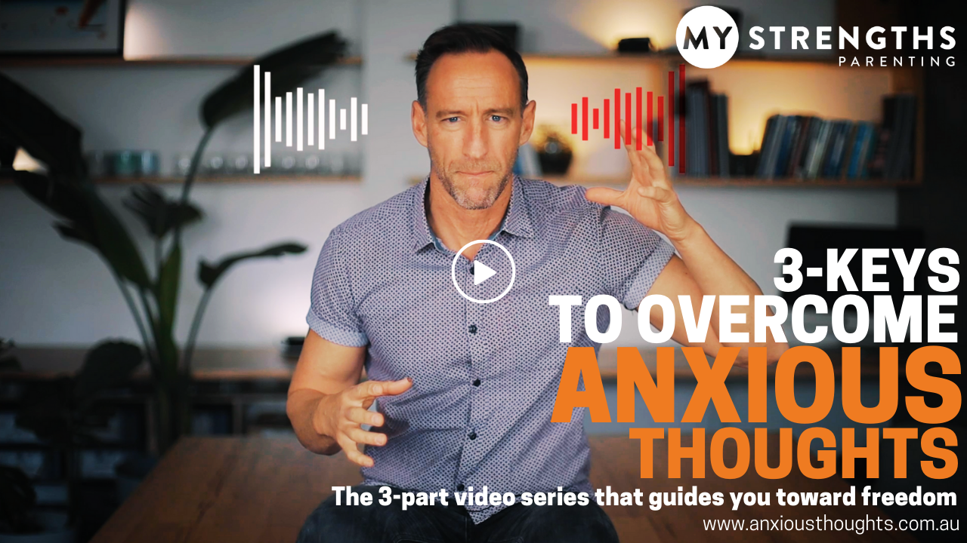

Short Blurb:
So many of us are struggling with worries and fear during this uncertain time. These anxious thoughts can be overwhelming and cause us to spiral into fear and despondence. With practical steps, our school partner, MyStrengths Australia, have a free 3-part series that bring the 3-Keys to take back control and overcome.

We recommend this Free Mini-Course, now available at www.anxiousthoughts.com.au

Longer Blurb:
COVID brings a level of uncertainty and angst that is affecting all of us. Not only are the circumstances difficult, the mental battles are equally challenging. For many students and parents alike, we battle with anxious thoughts that can be intrusive and overwhelming. It is important that we support one another at this time, and we have a school partner who has a great resource available to you.

MyStrengths Australia have partnered with our school for a number of years, leading students to discover their strengths and develop a growth mindset. MyStrengths Founder, Dan Hardie, has been passionate about helping students and parents alike, and has created a short online series that will help you and your children to better handle the anxious thoughts at this time. This 3-part series is FREE to all school partners, and will help you take steps to overcome.

We recommend you take this Free Mini-Course, now available at www.anxiousthoughts.com.au

